Assignment 5 Arduino Application

Released Date: Nov 13th

Version 1.0

Format: Name the document in the combination of name、ID and No. of Assignment.

**Example: Ping Yi_23_Assignment1.doc**

**Email the document to “pingy@wxit.edu.cn” before Nov 20th.**

**Task** Design a circuit using a temperature sensor, three LEDs indicate different levels of temperature stages, the detailed information will be displayed on LCD1602. Once the simulated temperature is over the 60 degrees Celsius, then the piezo will give an alarm to indicate overheating.

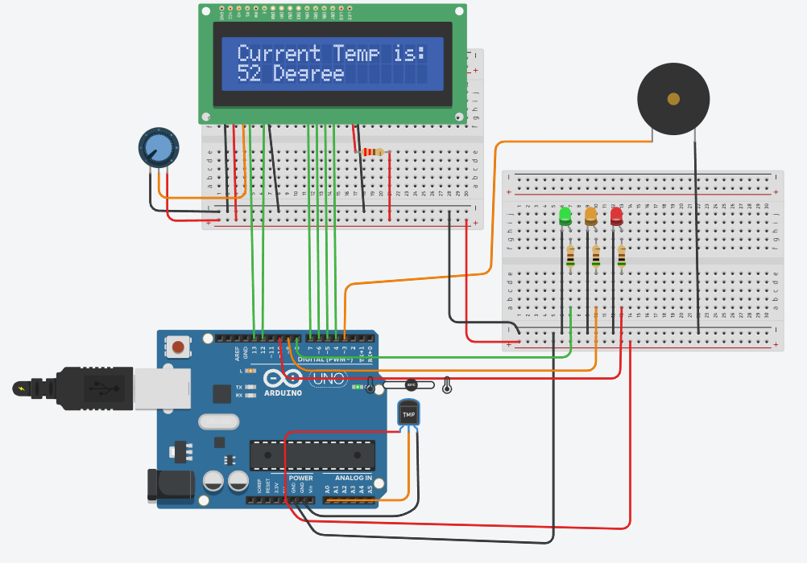

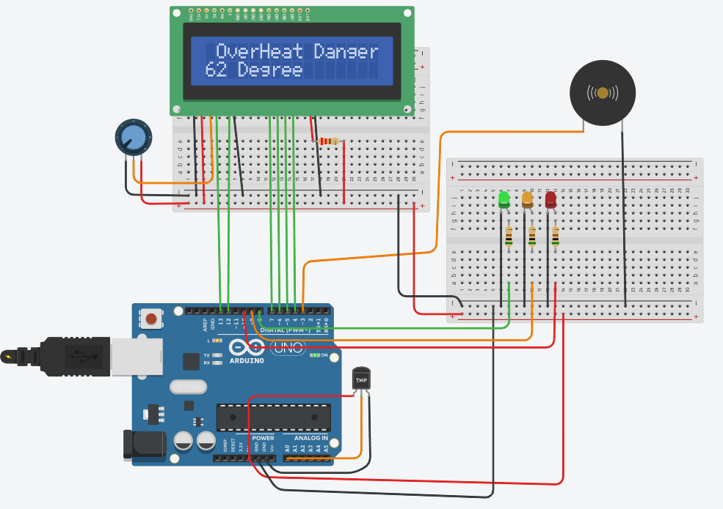

1. 1.#include <LiquidCrystal.h>
2. 2.LiquidCrystal lcd(13, 12, 7, 6, 5, 4);
3. 3.int baselineTemp=0;
4. 4.int celsius=0;
5. 5.int fahremheit=0;
6. 6.unsigned long tepTimer ;
7. 7.String ledColor[3]={"red","Greed","blue"};
8. 8.
9. 9.void setup(){
10. 10.  Serial.begin(9600);//设置波特率为9600 bps
11. 11.  pinMode(3,OUTPUT);// 蜂鸣器引脚设置
12. 12.  pinMode(8,OUTPUT);// 小灯引脚设置
13. 13.  pinMode(9,OUTPUT);
14. 14.  pinMode(10,OUTPUT);
15. 15.  lcd.begin(16,2);
16. 16.  lcd.setCursor(0,0);
17. 17.  lcd.print("Current Temp is:");
18. 18.}
19. 19.
20. 20.void loop(){
21. 21.  celsius = map(((analogRead(A0)-20)*3.04), 0, 1023, -40, 125);
22. 22.  fahremheit = ((celsius * 9)/5 + 32);//摄氏度华氏度的转换
23. 23.    lcd.setCursor(0,1);
24. 24.    lcd.print(celsius);
25. 25.    lcd.setCursor(4,1);//光标坐标
26. 26.    lcd.print("Degree");
27. 27.
28. 28.    Serial.print(celsius);
29. 29.    Serial.print(" C, "); // 串口输出摄氏度单位
30. 30.    Serial.print(fahremheit);
31. 31.    Serial.println(" F");// 串口输出华氏度单位
32. 32.
33. 33.    if(celsius<50){//温度小于50度的情况
34. 34.      lcd.setCursor(0,0);
35. 35.      lcd.print("Current Temp is:");
36. 36.      digitalWrite(8,HIGH);
37. 37.      digitalWrite(9,LOW);
38. 38.      digitalWrite(10,LOW);
39. 39.      digitalWrite(3,LOW);
40. 40.
41. 41.    }
42. 42.    if(celsius>=50&&celsius<60){//温在50到60度的情况
43. 43.      lcd.setCursor(0,0);
44. 44.      lcd.print("Current Temp is:");
45. 45.      digitalWrite(8,HIGH);
46. 46.      digitalWrite(9,HIGH);
47. 47.      digitalWrite(10,LOW);
48. 48.      digitalWrite(3,LOW);
49. 49.
50. 50.    }
51. 51.    if(celsius>=60){//温度大于60度的情况
52. 52.      lcd.setCursor(0,0);
53. 53.      lcd.print("Current Temp is:");
54. 54.      digitalWrite(8,HIGH);
55. 55.      digitalWrite(9,HIGH);
56. 56.      digitalWrite(10,HIGH);
57. 57.      digitalWrite(3,HIGH);
58. 58.
59. 59.    }
60. 60.}